AI & ML Based Pet Feeding System using Image Processing

In propose work we are utilizing AI based CNN (convolution neural network) deep learning algorithm to identify pet type and then suggest feeding details. This algorithm get trained on available images dataset and then this trained model can be applied on any new test image to predict pet type. We are trained this algorithm on 74 different type of pets and its performance evaluated in terms of prediction accuracy.

To implement this project we have defined following modules

1. Upload Pet Dataset: using this module we can upload pet dataset to application and then application will read each pet images and then extract features to create training array
2. Pre-process Dataset: loaded training features will be shuffle and normalize all pixel values
3. Train & Test Split: processed data will be split into train and test array where application using 80% dataset for training and 20% data for testing
4. Train CNN Algorithm: 80% training data will be input to CNN algorithm to train a model and this model will be applied on 20% test data to calculate prediction accuracy
5. Training Graph: this module will plot CNN training and validation accuracy graph
6. Pet Classification & Feeding System: using this module user will upload test image and then CNN will classify pet type and then suggest pet feeding food and the foods to avoid to maintain pet condition healthy.

SCREEN SHOTS

To run project double click on ‘run.bat’ file to get below page

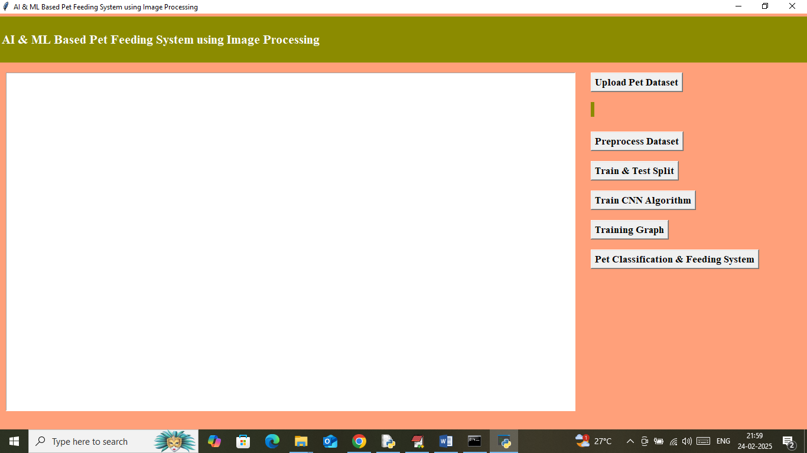

In above screen click on ‘Upload Pet Dataset’ button to load dataset and then will get below page

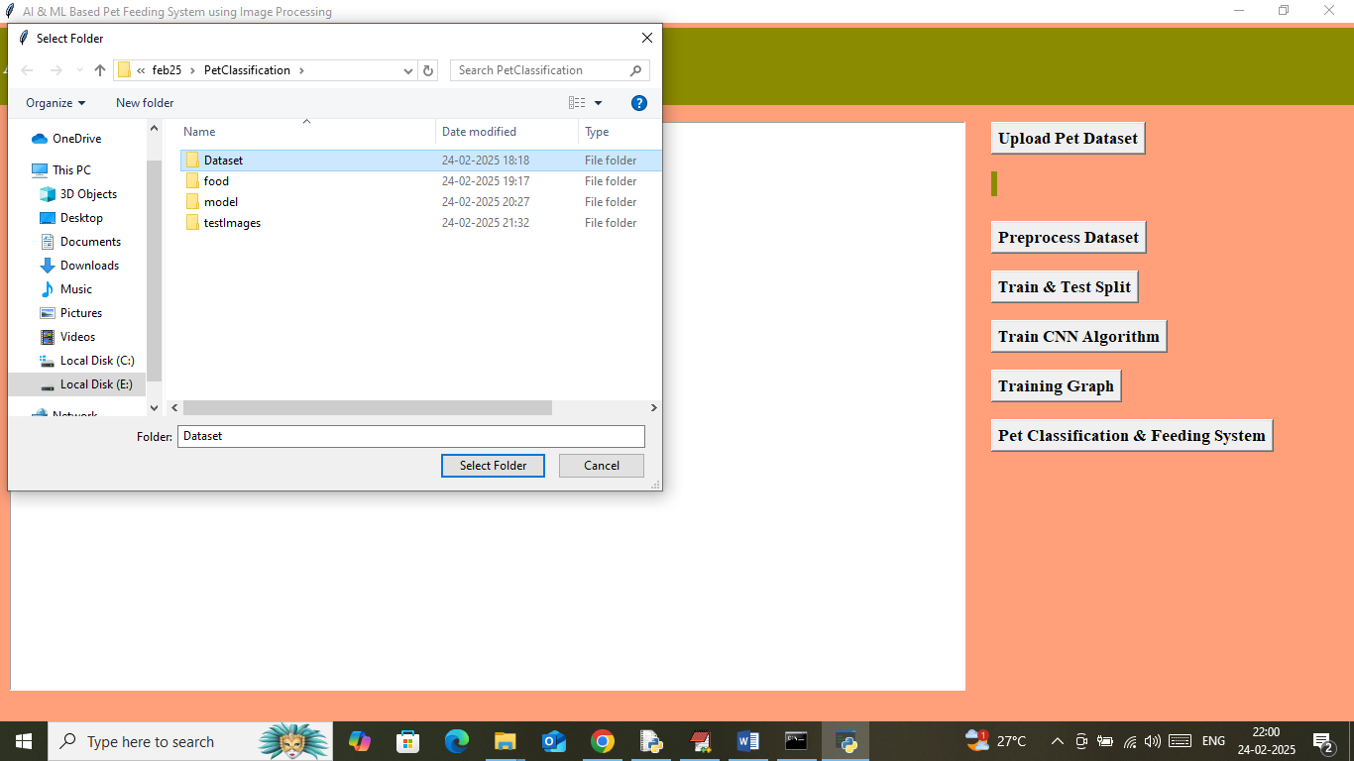

In above screen selecting and uploading entire dataset folder and then click on ‘Select Folder’ button to load dataset and then will get below page

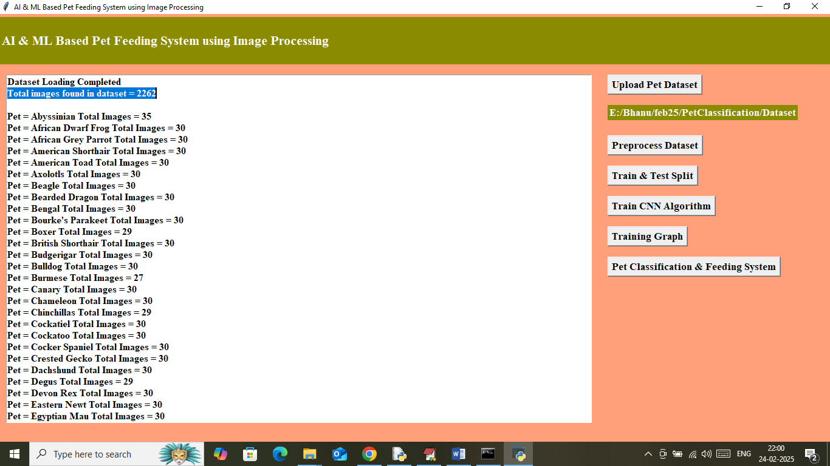

In above screen can see total number of images loaded from dataset and then can see different pets available in dataset along with number of images for each pet. Now click on ‘Pre-process Images’ button to shuffle and normalize image features and then will get below page

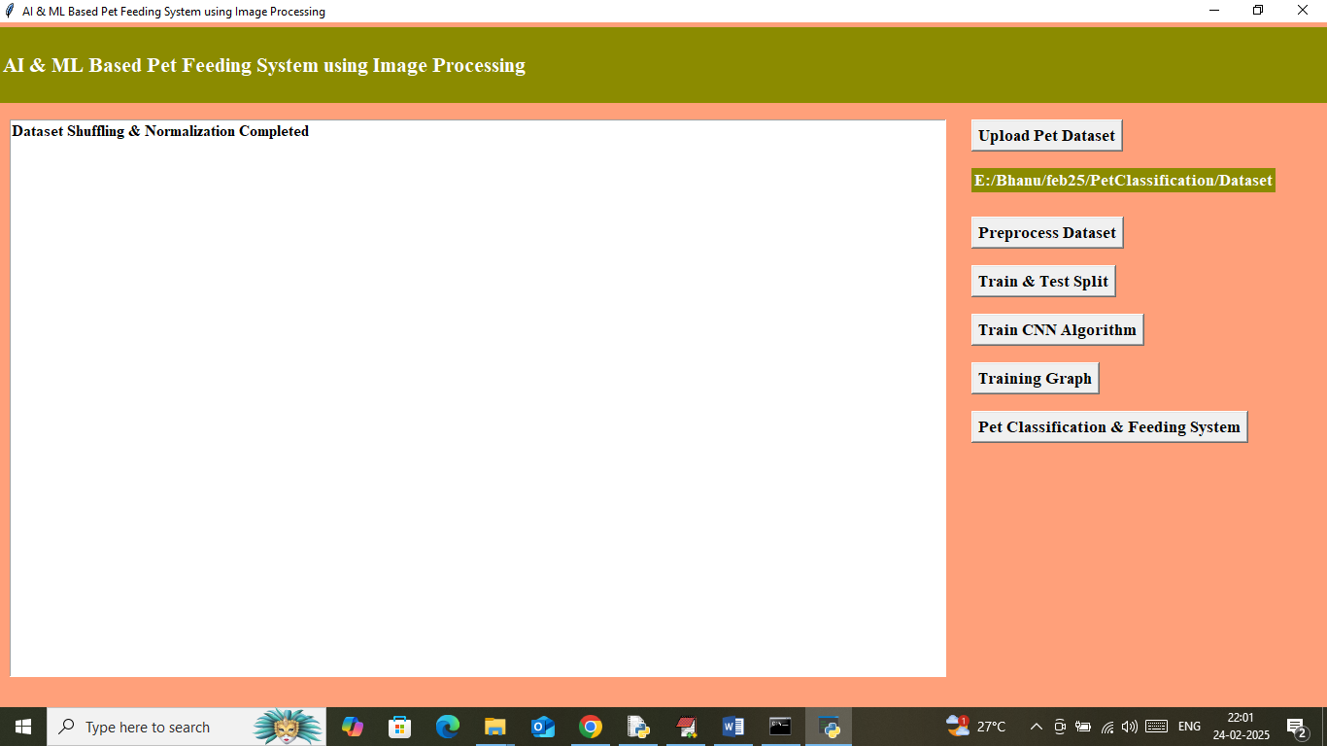

In above screen dataset processing completed and now click on ‘Train & Test Split’ button to split dataset into train and test and then will get below page

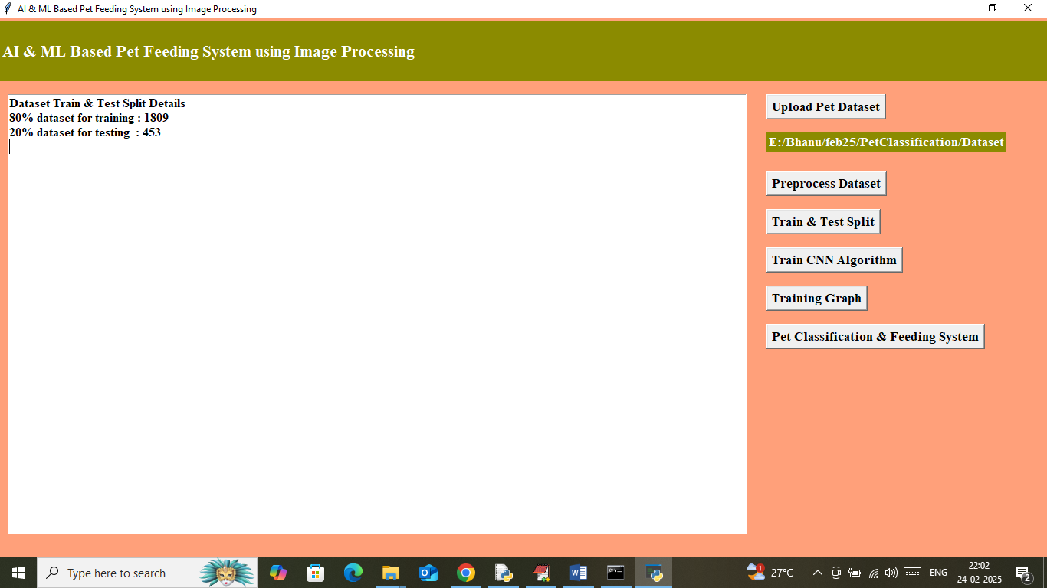

In above screen can see application using 1800 images for training and 450 images for testing and now click on ‘Train CNN Algorithm’ algorithm to train a model and then will get below page

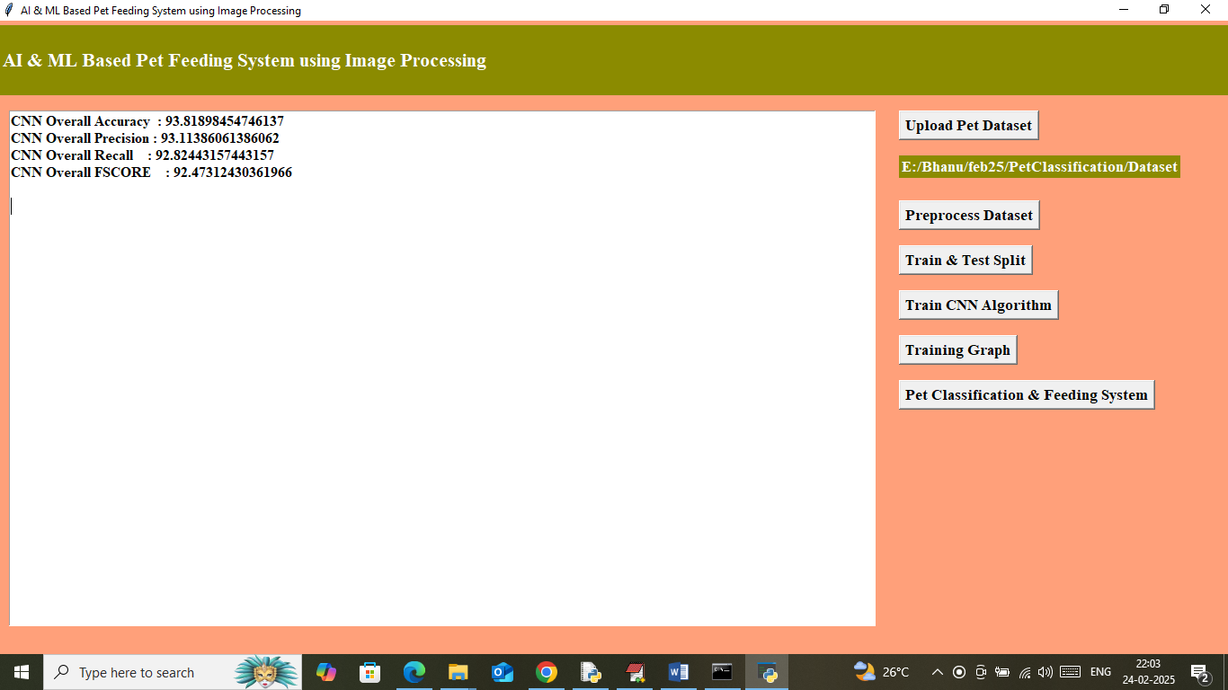

In above screen CNN training completed and its overall prediction accuracy is 93% and can see precision, recall and FCSORE. In below screen can see precision and recall percentage for each pet classification

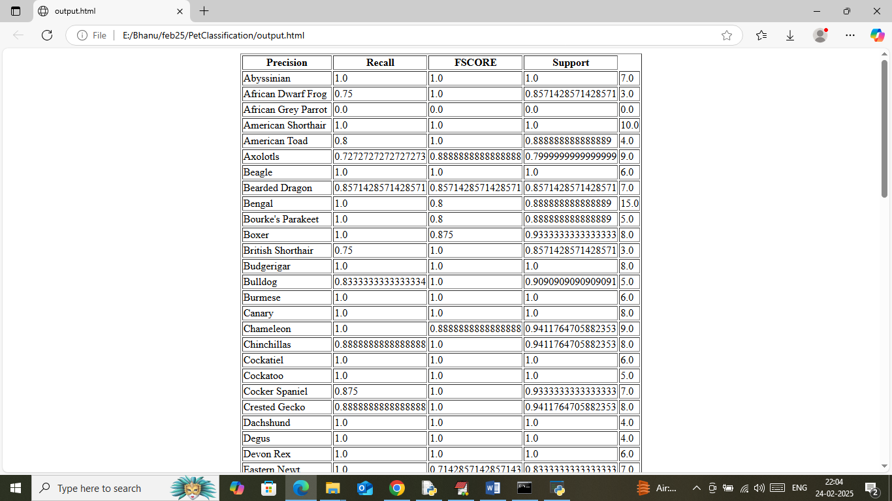

In above screen can see each pet is recognized with a precision of 80 to 100%. Now in application click on ‘Training Graph’ button to get below graph

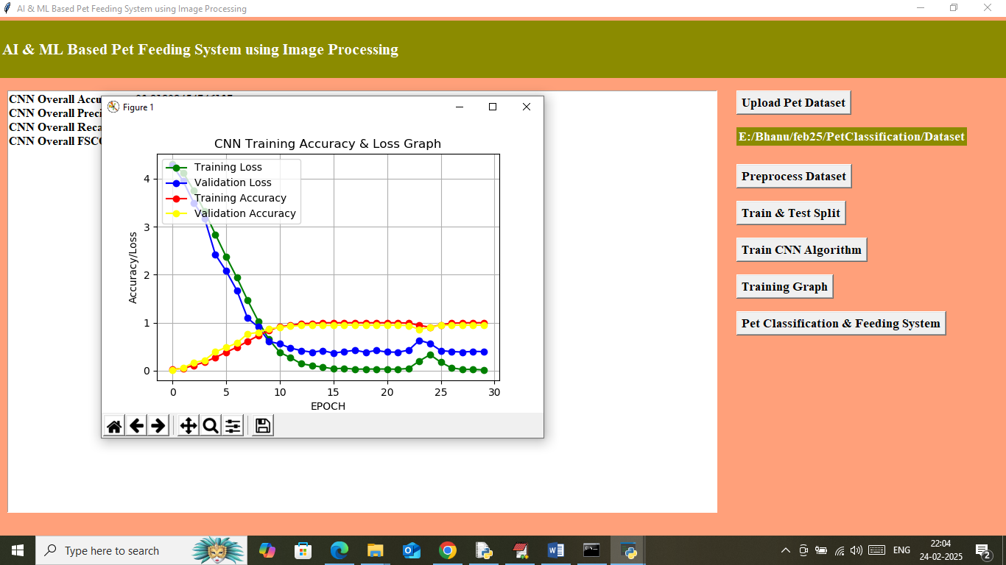

In above training graph x-axis represents ‘training epochs’ and y-axis represents accuracy and loss values. In above graph green line represents training loss and blue represents validations loss and then red represents training accuracy and yellow line represents validation accuracy. In above graph can see with each increasing epoch loss got decreased and reached closer to 0 and accuracy got increased and reached closer to 1. Now click on ‘Pet Classification & Feeding System’ button to upload test image and then will get below page

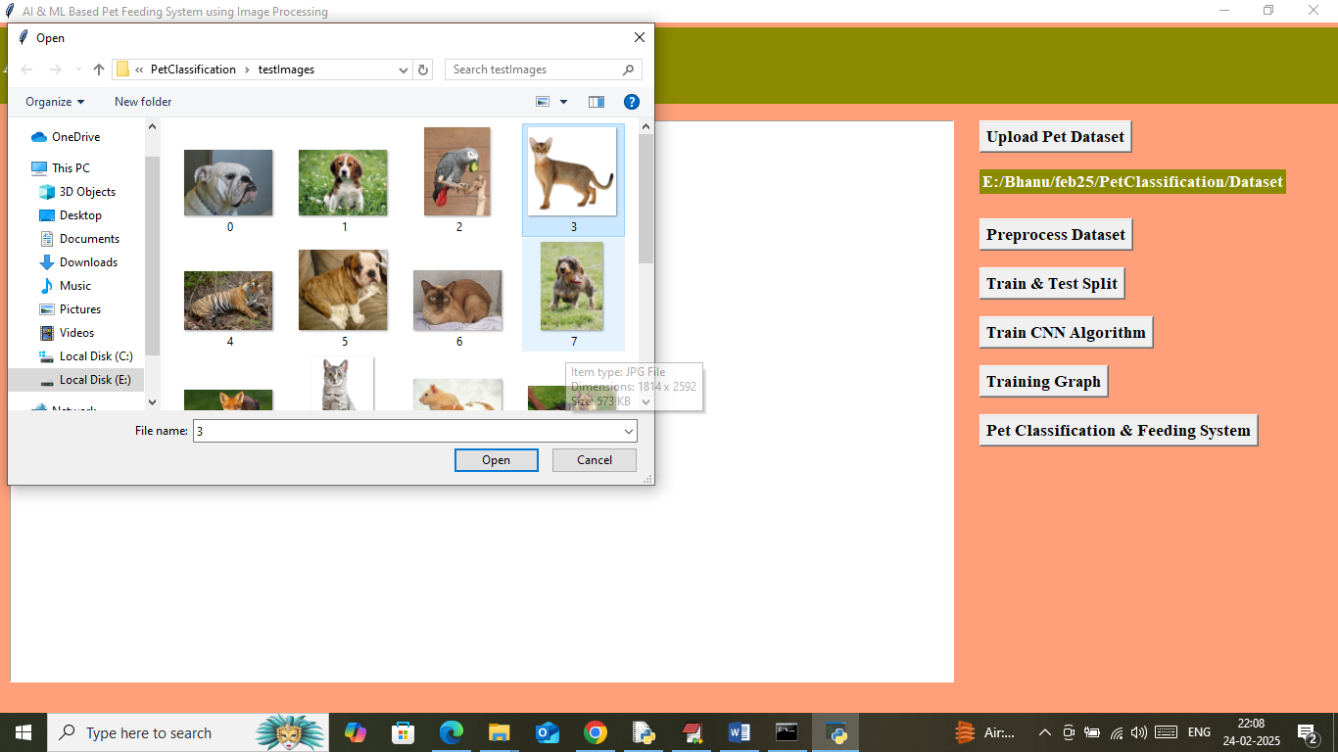

In above screen selecting and uploading test image and then will get below output

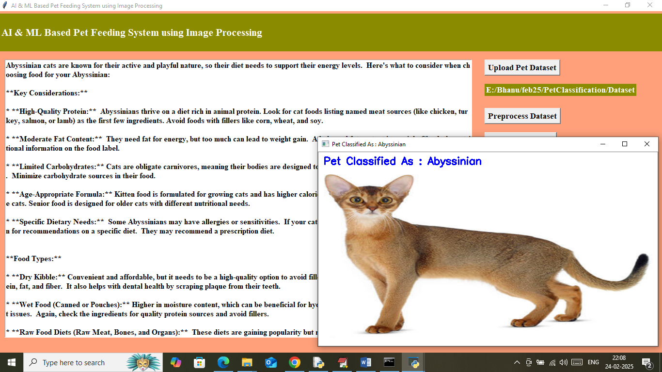

In above screen uploaded image pet recognized as ‘Abyssinian cats’ and in text area can see all details on food. Similarly you can upload and test other images

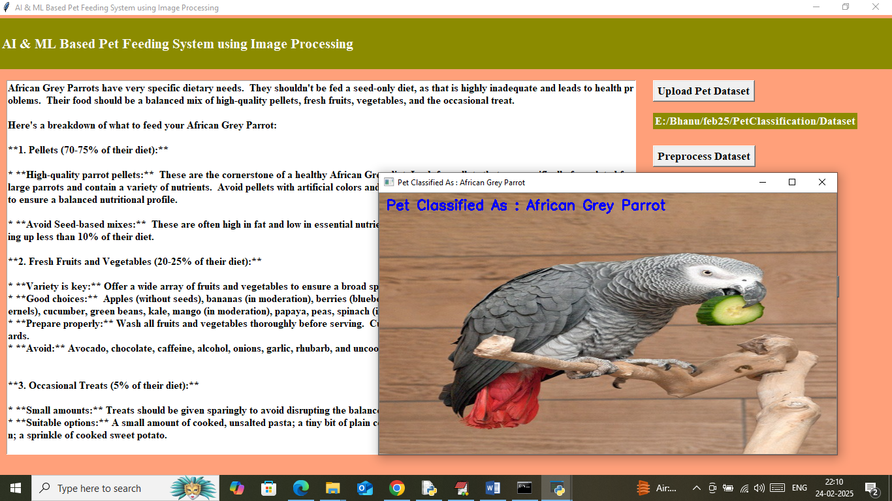

In above screen uploaded pet recognized as ‘Parrot’

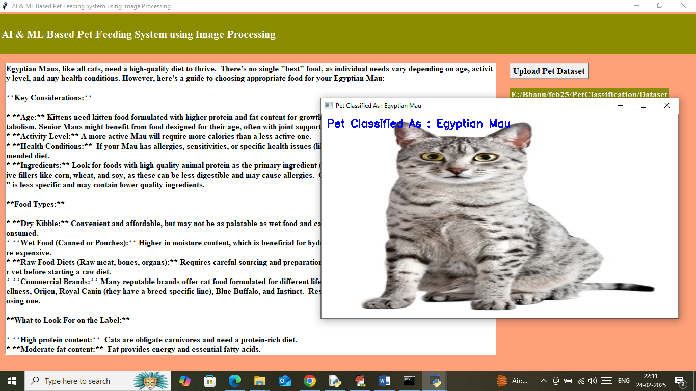

Above pet predicted as Egyptian Mau

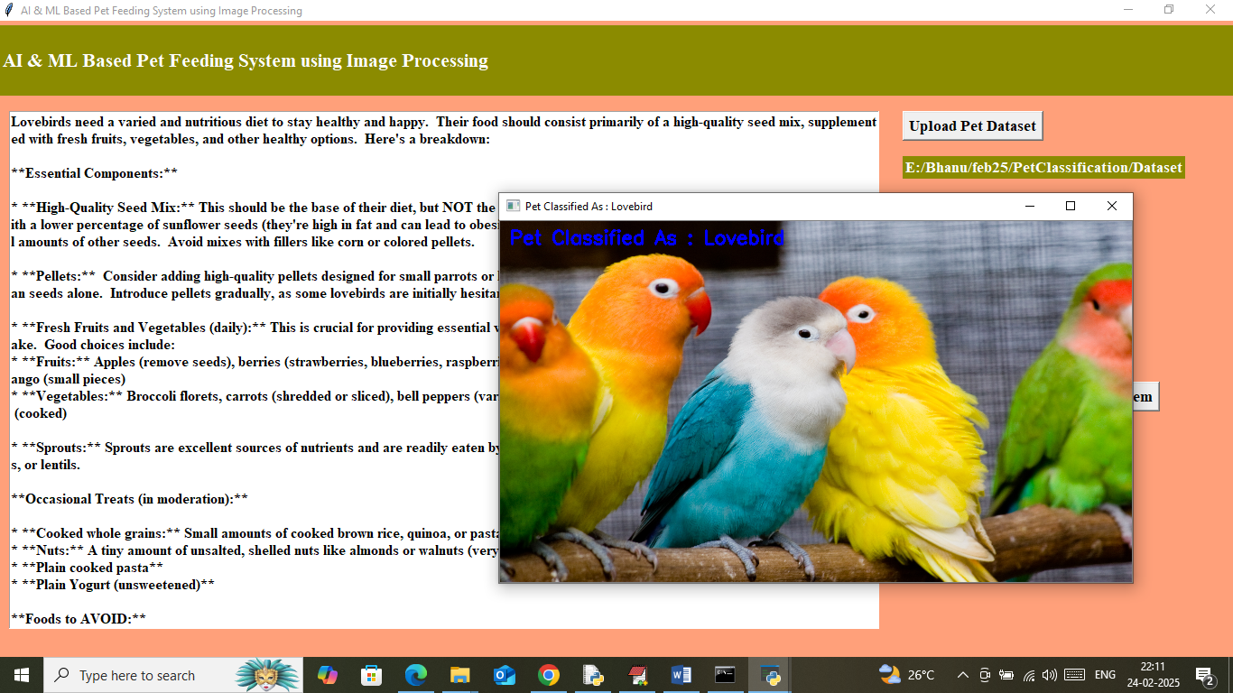

Above pet recognized as Birds.